ASSIGNMENT

Task-1: Complete the bucket policy assignment. If in your S3 bucket you have some .png files and some .pdf files, create a bucket policy to make the .png files accessible to all public users (without login). And restrict the .pdf files to the public users.

Solution:-

Stepswise solution

Step-1-> First of all we have to create s3 bucket and then select aws policy generator and then add the policy type and statement.

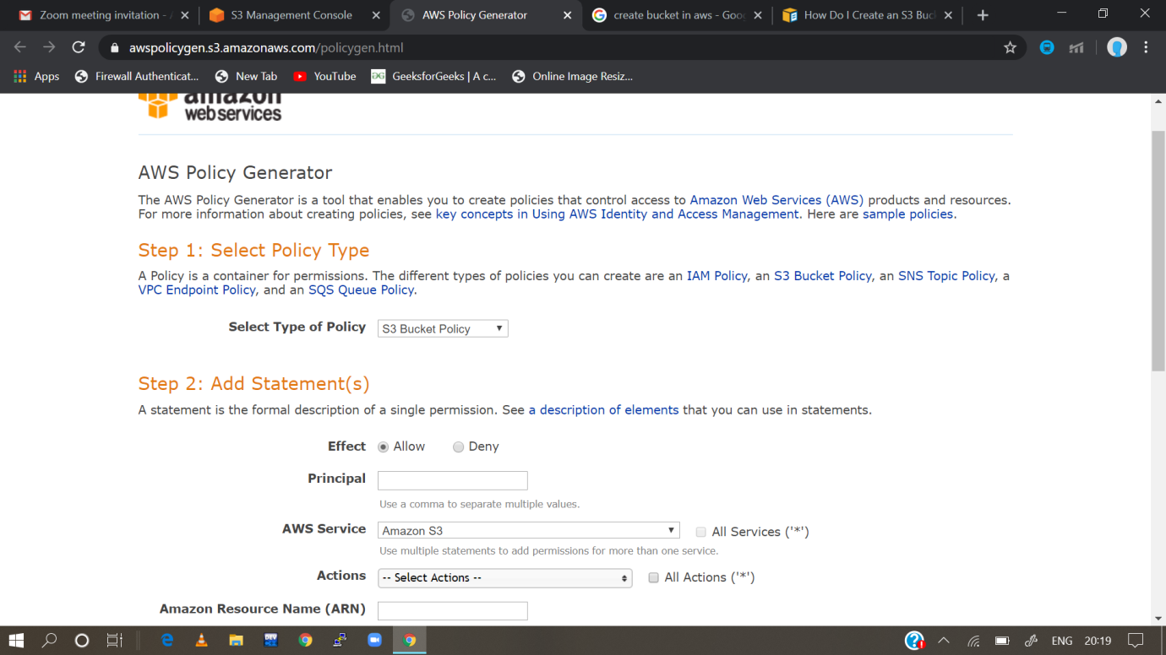

Step 2:- then after configuring and adding statements then we have to generate the policy

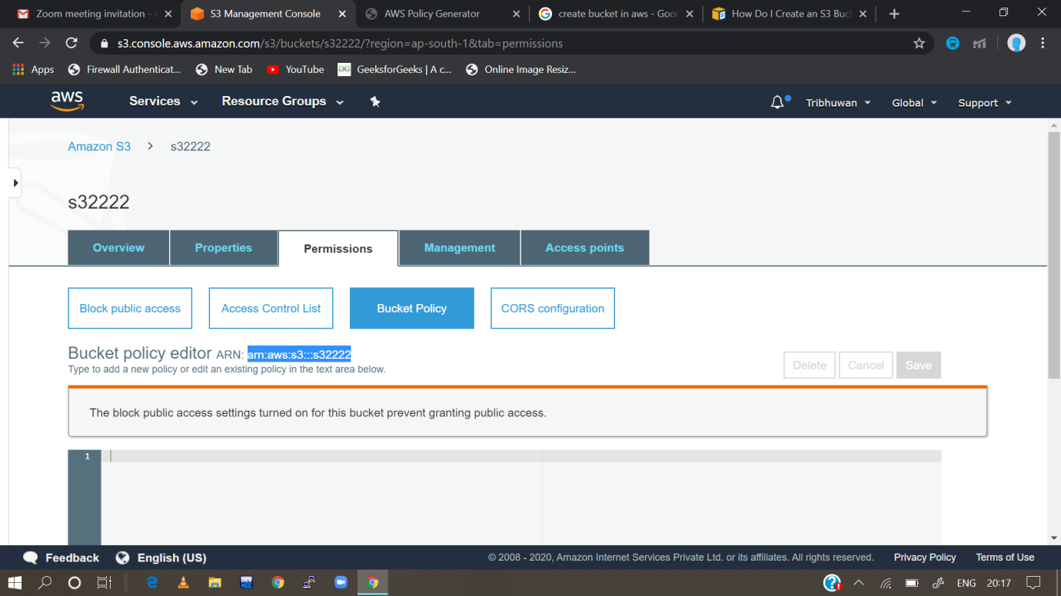

Step 3 - Then copy the json document policy to the policy generator and then save the script.

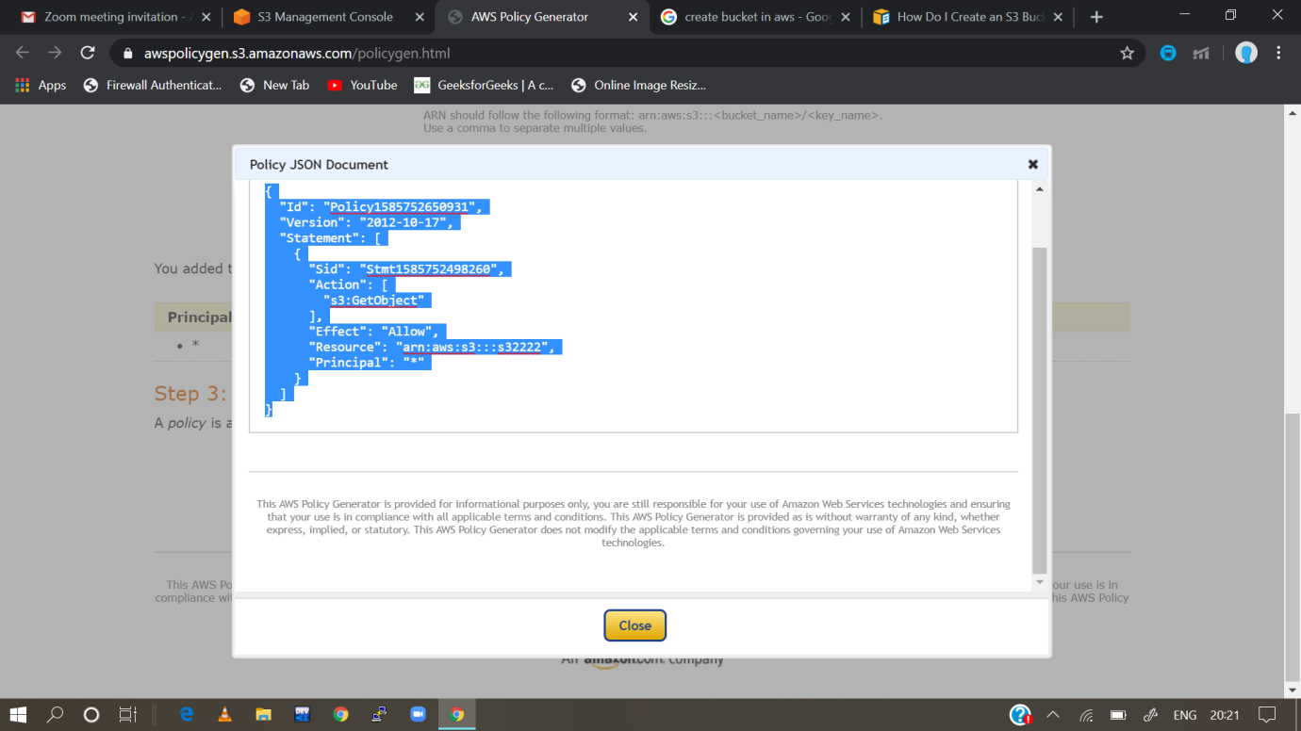

Step-4 upload some png file and some jpg or other files and then check the url

For the public access

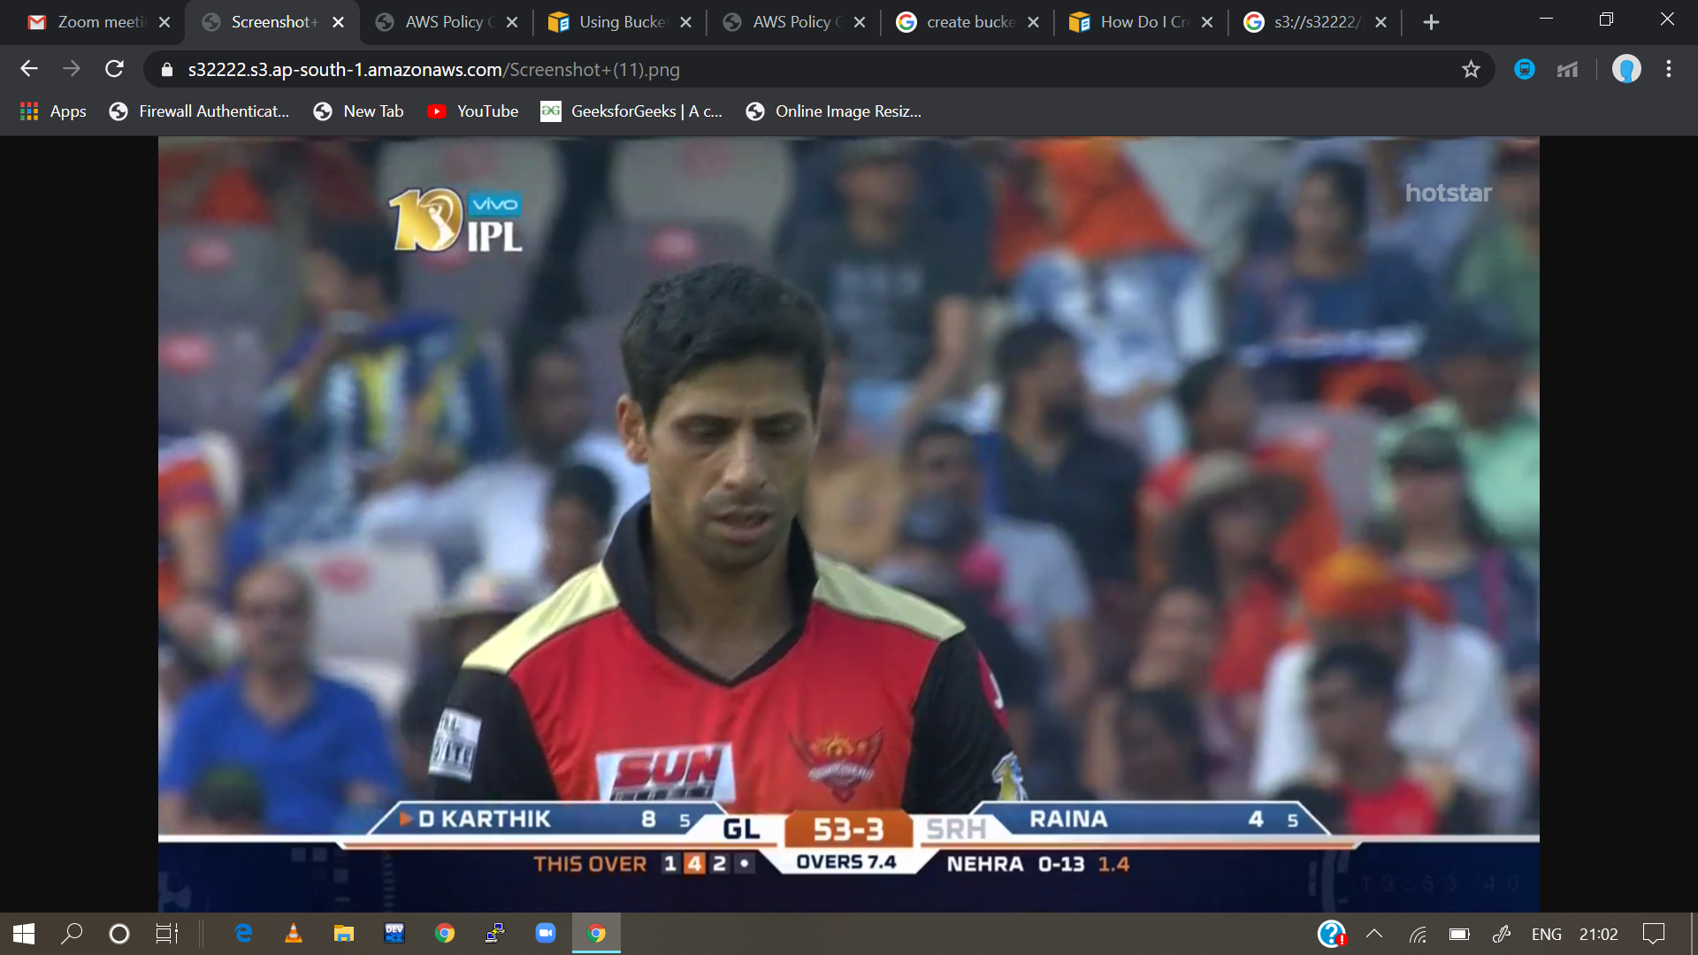

For the private access

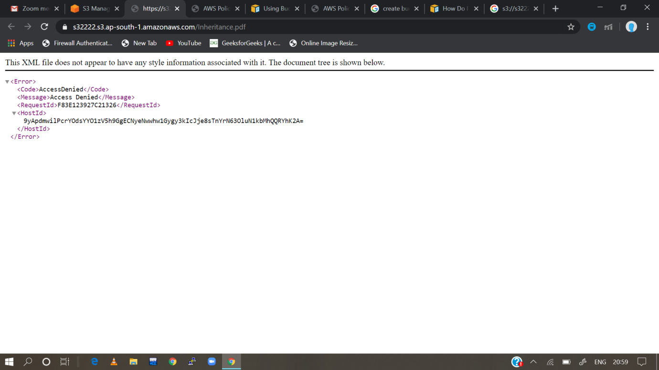

TASK-2- Write the steps to create an autoscaling group and associate the EC2 instances of that autoscaling group with an Application load balancer. When you click on the URL of Application load balancer, it should return the content from EC2 instances.

Steps

1. Create a Application Load Balance In the wizard, also create Target group but do not add any instances
2. Create an Autoscaling Group of any sizes but not less than 2.
3. Create Launch Configuration.
4. Make sure you add userdata (see below) to download and install website

Associate Target group with Autoscaling group

Associate ELB health check

1. Wait for instances to be running

See if you are able to access your Web Application using Load balancer DNS Increase the load on the web server

Login to any of the EC2 over ssh (Make sure 22 port is open)

Install stress: sudo yum install stress –y

6. Increase system load: stress --cpu 8 -timeout 300 Wait for 5 mins and see if scaling activities happen